EXP-2
CODE:2A
clc;
clear;
close all;
Am = 1.5;
Ac = 8;
fm = 50;
fc = 500;
beta = 3;
fs = 10000;
t = 0:1/fs:1;
m = Am*cos(2*pi*fm*t);
c = Ac*cos(2*pi*fc*t);
fm_sig = Ac*cos(2*pi*fc*t + beta*sin(2*pi*fm*t));
inst_freq = fc + beta*fm*cos(2*pi*fm*t);
figure('Name','Frequency Modulation','NumberTitle','off');
subplot(4,1,1);plot(t,m,'LineWidth',1.5);title('Message Signal');xlabel('Time(s)');ylabel('Amplitude');grid on;
subplot(4,1,2);plot(t,c,'LineWidth',1.5);title('Carrier Signal');xlabel('Time (s)');ylabel('Amplitude');grid on;
subplot(4,1,3);plot(t,fm_sig,'LineWidth',1.5);title('FM Signal');xlabel('Time (s)');ylabel('Amplitude');grid on;
subplot(4,1,4);plot(t,inst_freq,'LineWidth',1.5);title('Instantaneous Frequency');xlabel('Time (s)');ylabel('Frequency (Hz)');grid on;
fprintf('Message Frequency = %d Hz\n', fm);
fprintf('Carrier Frequency = %d Hz\n', fc);
fprintf('Modulation Index = %.2f\n', beta);
fprintf('Maximum Frequency Deviation = %.2f Hz\n', beta*fm);
fprintf('Bandwidth (Carson Rule) = %.2f Hz\n', 2*(beta*fm + fm));

OUTPUT :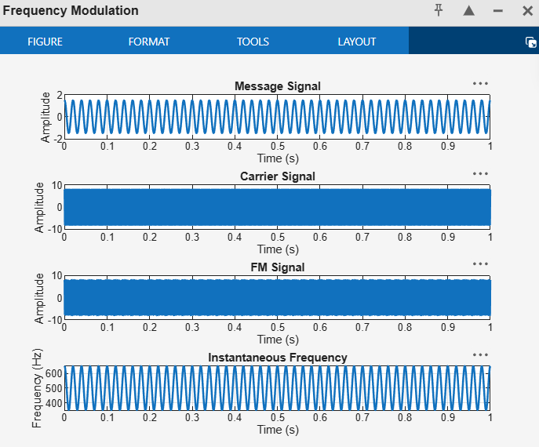
CODE:2A.1
clc;
clear;
close all;
%% Input Parameters
Am = 1; % Message signal amplitude (V)
fm = 1000; % Message frequency (Hz)
Ac = 5; % Carrier amplitude (V)
fc = 20000; % Carrier frequency (Hz)
kf = 5000; % Frequency sensitivity (Hz/V)
fs = 200000; % Sampling frequency (Hz)
T = 0.01; % Simulation duration (s)
t = 0:1/fs:T;
%% Message Signal
m = Am*cos(2*pi*fm*t);
%% Frequency Deviation
delta_f = kf * Am;
%% Modulation Index
beta = delta_f / fm;
%% FM Signal
fm_signal = Ac*cos(2*pi*fc*t + beta*sin(2*pi*fm*t));
%% Plot Message Signal
figure('Name','Frequency Modulation','NumberTitle','off');
subplot(2,1,1);plot(t,m,'LineWidth',1.5);title('MessageSigna');xlabel('Time (s)');ylabel('Amplitude');grid on;
%% Plot FM Signal
subplot(2,1,2);plot(t,fm_signal,'LineWidth',1.5);title('Frequency Modulated Signal');xlabel('Time (s)');ylabel('Amplitude');
grid on;
%% Spectrum Analysis
N = length(fm_signal);
FM_fft = fftshift(abs(fft(fm_signal))/N);
f = (-N/2:N/2-1)*(fs/N);
figure('Name','FM Spectrum','NumberTitle','off');
plot(f,FM_fft,'LineWidth',1.5);
title('FM Signal Spectrum');
xlabel('Frequency (Hz)');
ylabel('Magnitude');
grid on;
xlim([fc-15000 fc+15000]);
%% Display Results
fprintf('\nFM SIGNAL PARAMETERS\n');
fprintf('-----------------------------\n');
fprintf('Carrier Frequency = %.0f Hz\n', fc);
fprintf('Message Frequency = %.0f Hz\n', fm);
fprintf('Message Amplitude = %.2f V\n', Am);
fprintf('Carrier Amplitude = %.2f V\n', Ac);
fprintf('Frequency Sensitivity = %.0f Hz/V\n', kf);
fprintf('\nCALCULATED VALUES\n');
fprintf('-----------------------------\n');
fprintf('Frequency Deviation (Delta f) = %.0f Hz\n', delta_f);
fprintf('Modulation Index (Beta) = %.2f\n', beta);
%% Carson's Rule Bandwidth
BW = 2*(delta_f + fm);
fprintf('Bandwidth (Carson Rule) = %.0f Hz\n', BW);
OUTPUT :

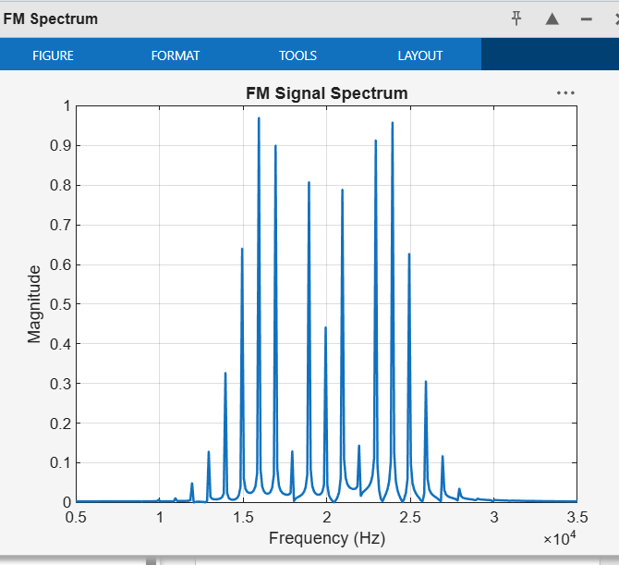

CC:

CODE :2B

clc;
clear;
close all;
Am = 1;
fm = 1000;
Ac = 5;
fc = 20000;
%% FM Parameters
kf = 4000;
fs = 200000;
T = 0.01;
%% Time Vector
t = 0:1/fs:T;
%% Message Signal
m = Am*cos(2*pi*fm*t);
%% Frequency Deviation
delta_f = kf * Am;
%% Modulation Index
beta = delta_f / fm;
%% FM Signal
fm_signal = Ac*cos(2*pi*fc*t + beta*sin(2*pi*fm*t));
%% Display Parameters
fprintf('Carrier Frequency (fc) = %.0f Hz\n', fc);
fprintf('Message Frequency (fm) = %.0f Hz\n', fm);
fprintf('Message Amplitude (Am) = %.2f V\n', Am);
fprintf('Carrier Amplitude (Ac) = %.2f V\n', Ac);
fprintf('Frequency Sensitivity (kf) = %.0f Hz/V\n', kf);
fprintf('\nFrequency Deviation (Delta f) = %.2f Hz\n', delta_f);
fprintf('Modulation Index (Beta) = %.2f\n', beta);
%% Verification
beta_verify = delta_f / fm;
fprintf('Verified Modulation Index = %.2f\n', beta_verify);
%% Verification Check
tolerance = 1e-6;
if abs(beta - beta_verify) < tolerance
fprintf('\nVerification Successful\n');
else
fprintf('\nVerification Failed\n');
end
%% Plotting
figure('Name','FM Modulation','NumberTitle','off');
subplot(2,1,1);
plot(t,m,'LineWidth',1.5);
grid on;
title('Message Signal');
xlabel('Time (s)');
ylabel('Amplitude (V)');
subplot(2,1,2);
plot(t,fm_signal,'LineWidth',1.2);
grid on;
title('FM Signal');
xlabel('Time (s)');
ylabel('Amplitude (V)');
OUTPUT :

